**Nama: Thesya Marcella**

**NPM: 202310020**

**Kelas: 20-TI-PA1**

**LOGIN DAN REGISTER**

**_____________________________________________________________________________________**

**Login.html**

<!DOCTYPE html>

<html lang="en">

<head>

    <meta charset="UTF-8">

    <meta http-equiv="X-UA-Compatible" content="IE=edge">

    <meta name="viewport" content="width=device-width, initial-scale=1.0">

    <title>Login</title>

    <link rel="stylesheet" href="s.css">

    <link rel="preconnect" href="https://fonts.googleapis.com">

    <link rel="preconnect" href="https://fonts.gstatic.com" crossorigin>

    <link href="https://fonts.googleapis.com/css2?family=Montserrat:wght@200;400;700&display=swap" rel="stylesheet">

</head>

<body>

      <div class="overlay"></div>

      <form action="index.html" method="post"class="box">

          <div class="header">

              <h3>Login</h3>

          </div>

          <div class="Login-area">

              <label for="username">Username</label>

              <input type="username" class="username" placeholder="Enter Username">

              <label for="password">password</label>

              <input type="password" class="password" placeholder="Enter Password">

              <input type="submit" value="Login" class="submit">

              <button class="register"

              onclick="window.location.href = 'register.html';">

                  Register

              </button>

          </div>

      </form>

</body>

</html>

**Login.css**

body {

    padding: 0;

    margin: 0;

    background-image: url(img/background.jpg);

    background-size: cover;

    font-family: 'Montserrat', sans-serif;

}

.overlay {

    position: absolute;

    top: 0;

    width: 100%;

    height: 100%;

    background-color: rgba(0, 0, 0, .05);

}

.box {

    position: absolute;

    width: 400px;

    background-image: url(img/background.jpg);

    top:50%;

    left:50%;

    transform: translate(-50%,-50%);

    border-radius: 10px;

    box-shadow: 0 10px 10px 10px rgba(0, 0, 0, 0.2);

    color: rgb(201, 234, 238);

}

.header {

    color: black;

    font-size: x-large;

    text-align: center;

    font-weight: bold;

}

.Login-area {

    padding: 0px 50px 30px 50px;

}

.Login-area > label {

    font-weight: bold;

    color:rgb(110, 64, 89);

    letter-spacing: 0.8 px;

    margin-bottom: 30px;

}

.username,

.password {

    height: 45px;

    width: 100%;

    outline: none;

    font-size: 16px;

    border-radius: 15px;

    padding-left: 15px;

    border: 1px solid #ccc;

    border-bottom-width: 2px;

    transition: all 0.3s ease;

}

.username::placeholder,

.password::placeholder {

    color: rgb(192, 168, 181);

}

.username:focus,

.password:focus{

    background-color: rgb(255, 240, 248);

}

.username:valid,

.password:valid{

  border-color:  #a0c3eb;

}

.register{

    width: 100px;

    padding: 10px;

    background-color: rgb(255, 240, 248);

    font-weight: bold;

    border-radius: 20px;

    color: rgb(139, 102, 122);

    border: none;

    outline: none;

    margin: 10px;

    transition: .2s;

    cursor: pointer;

}

.submit {

    width: 100px;

    padding: 10px;

    background-color: rgb(139, 102, 122);

    font-weight: bold;

    border-radius: 20px;

    color: white;

    border: none;

    outline: none;

    margin: 10px;

    transition: .2s;

    cursor: pointer;

}

.submit:hover {

    background-color: rgb(97, 55, 77);

}

.register:hover {

        background-color: rgb(224, 188, 207);

}

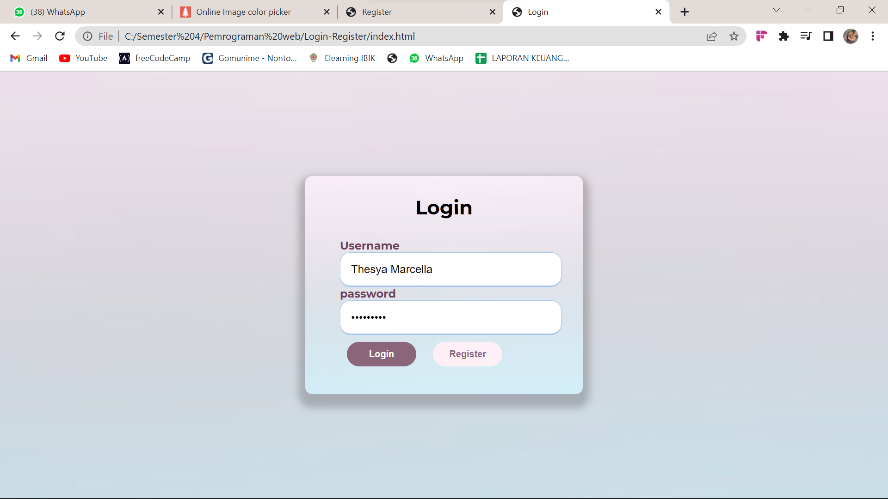

**Register.html**

<!DOCTYPE html>

<html lang="en">

<head>

    <meta charset="UTF-8">

    <meta http-equiv="X-UA-Compatible" content="IE=edge">

    <meta name="viewport" content="width=device-width, initial-scale=1.0">

    <title>Register</title>

    <link rel="stylesheet" href="register.css">

</head>

<body>

    <div class="container">

         <div class="title"><h3>Registrasi</h3></div>

         <form action="#">

             <div class="user-details">

                <div class="input-box">

                    <span class="details">NPM</span>

                    <input type="text" placeholder="200000210" required>

                </div>

                 <div class="input-box">

                     <span class="details">Nama Lengkap</span>

                     <input type="text" placeholder="Teca Marcell" required>

                 </div>

                 <div class="input-box">

                    <span class="details">Nama Pengguna</span>

                    <input type="text" placeholder="thesyamarcella" required>

                </div>

                <div class="input-box">

                    <span class="details">Email</span>

                    <input type="text" placeholder="xxxxx@gmail.com" required>

                </div>

                <div class="input-box">

                    <span class="details">Kata Sandi</span>

                    <input type="text" placeholder="********" required>

                </div>

                <div class="input-box">

                    <span class="details">Tempat Lahir</span>

                    <input type="text" name="placebirth1" value="" placeholder="ex: Bogor">

                </div>

                <div class="input-box">

                    <span class="details">Tanggal Lahir</span>

                    <input type="date" name="date1" value="" placeholder="Tanggal Lahir Anda">

                </div>

                <div class="gender-details">

                    <input type="radio" name="gender" id="dot-1">

                    <input type="radio" name="gender" id="dot-2">

                    <input type="radio" name="gender" id="dot-3">

                    <span class="gender-title">Jenis Kelamin</span>

                    <div class="category">

                      <label for="dot-1">

                      <span class="dot one"></span>

                      <span class="gender">Laki-laki</Laki-laki></span>

                    </label>

                    <label for="dot-2">

                      <span class="dot two"></span>

                      <span class="gender">Perempuan</span>

                    </label>

                    </div>

                  </div>

                  <div class="input-box">

                    <span class="details">Alamat</span>

                    <textarea name="" id="" cols="30" rows="10" placeholder="Masukkan Alamat Anda"></textarea>

                </div>

             <div class="button">

                 <input type="submit" Value="Registrasi">

             </div>

         </form>

</div>

</body>

</html>

**Register.css**

    @import url('https://fonts.googleapis.com/css2?family=Montserrat:wght@200;400;700&display=swap');

    *{

    margin: 0;

    padding: 0;

    box-sizing: border-box;

    font-family: 'Montserrat', sans-serif;

}

body{

  height: 100vh;

  display: flex;

  justify-content: center;

  align-items: center;

  padding: 10px;

  background: linear-gradient(100deg, #d6eef8, #f3e9f2);

}

.container{

  max-width: 600px;

  width: 500px;

  background-image: url(img/background.jpg);

  padding: 20px 30px;

  border-radius: 10px;

  box-shadow: 0 10px 10px 10px rgba(0, 0, 0, 0.2);

}

.container .title{

  font-size: x-large;

  font-weight: bold;

  text-align: center;

  position: relative;

  margin-top: 40px;

  margin-bottom: 15px;

}

.content form .user-details{

  display: flex;

  flex-wrap: wrap;

  justify-content: space-between;

  margin: 20px 0 12px 0;

}

form .user-details .input-box{

  margin-bottom: 15px;

  width: calc(100% / 2 - 20px);

}

form .input-box span.details{

  display: block;

  font-weight: bold;

  margin-bottom: 5px;

  color:rgb(110, 64, 89);

}

.user-details .input-box input{

  height: 45px;

  width: 100%;

  outline: none;

  font-size: 16px;

  border-radius: 15px;

  padding-left: 15px;

  border: 1px solid #ccc;

  border-bottom-width: 2px;

  transition: all 0.3s ease;

}

.user-details .input-box input:focus,

.user-details .input-box input:valid{

  border-color:  #a0c3eb;

}

 form .gender-details .gender-title{

  font-size: 20px;

  font-weight: 500;

 }

 form .category{

   display: flex;

   width: 80%;

   margin: 14px 0 ;

   justify-content: space-between;

 }

 form .category label{

   display: flex;

   align-items: center;

   cursor: pointer;

 }

 form .category label .dot{

  height: 18px;

  width: 18px;

  border-radius: 50%;

  margin-right: 10px;

  background: #f3e9f2;

  border: 5px solid transparent;

  transition: all 0.3s ease;

}

 #dot-1:checked ~ .category label .one,

 #dot-2:checked ~ .category label .two,

 #dot-3:checked ~ .category label .three{

   background: #a0c3eb;

   border-color: #f3e9f2;

 }

 form input[type="radio"]{

   display: none;

 }

 form .button{

   height: 45px;

   margin: 35px 0

 }

 form .button input{

   height: 100%;

   width: 100%;

   border-radius: 15px;

   border: none;

   color: #fff;

   font-size: 18px;

   font-weight: 500;

   letter-spacing: 1px;

   cursor: pointer;

   transition: all 0.3s ease;

   background: linear-gradient(100deg, #a4def7, #a0c3eb, #e6c0e1);

 }

 form .button input:hover{

  /* transform: scale(0.99); */

  background: linear-gradient(-135deg, #d6eef8, #f3e9f2);

  }

 @media(max-width: 584px){

 .container{

  max-width: 100%;

}

form .user-details .input-box{

    margin-bottom: 15px;

    width: 100%;

  }

  form .category{

    width: 100%;

  }

  .content form .user-details{

    max-height: 300px;

    overflow-y: scroll;

  }

  .user-details::-webkit-scrollbar{

    width: 5px;

  }

  }

  @media(max-width: 459px){

  .container .content .category{

    flex-direction: column;

  }

}

